Week 05

Xiaokuan Zhao

Problem 1

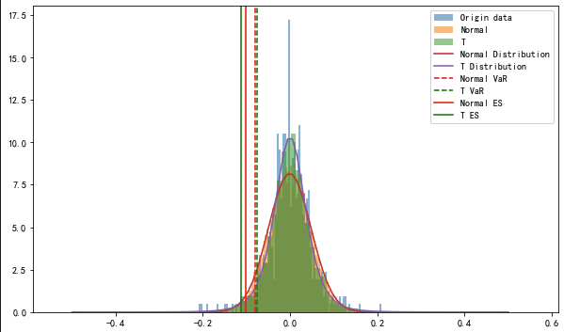

From the graph, we can see that T distribution is a better measure than normal distribution in this problem because it plots the original data better. Also, the Expected Shortfall of T distribution is much smaller than ES of normal distribution. On the other hand, the VaR of T distribution is a little larger than VaR of normal distribution. Both distribution did not successfully measure the fat tail.

Problem 2

All functions perform as expected.

Problem3

Portfolio A VaR: 1929.26

Portfolio A ES: 2465.61

Portfolio B VaR: 1850.78

Portfolio B ES: 2329.33

Portfolio C VaR: 1608.30

Portfolio C ES: 2048.85

Portfolio Total VaR: 3129.91

Portfolio Total ES: 3915.34

Comparing to Week 4’s result, we can see the VaR and ES under the assumption of T distribution is much lower.